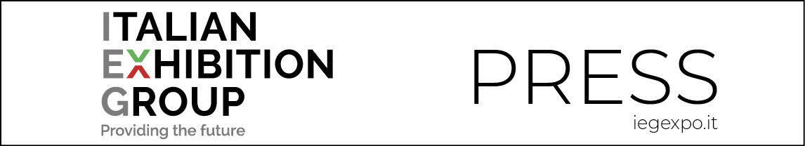

press release
(English translation)

IEG BRASIL IS FOUNDED AND ACQUIRES THE BRASIL TRADING FITNESS FAIR

Italian Exhibition Group has founded a new company in South America and acquires BTFF,
one of the country's most representative sports events.

"IEG is working intensively on its progressive strengthening on foreign markets,
says CEO Corrado Peraboni, "today's announcement is a further step in our '4x4 business project', which aims at enhancing the leading products in our portfolio".

Rimini, 24 January 2022 – Italian Exhibition Group continues to grow on foreign markets and announces the birth of IEG Brasil, a new company that will work on the opportunities offered by the Brazilian market in sectors synergic with the company's portfolio.

IEG Brasil immediately introduces itself with an important result: the recently concluded acquisition of BTFF - Brasil Trading Fitness Fair, one of the country's most representative events in the sports sector. Building on the experience of RiminiWellness in Italy, the Dubai Muscle and Active Show in the Emirates and Mexico Active&Sport in Leon, IEG is, in fact, aiming at the second largest market in the world after the United States, with 34,000 gyms and double-digit annual growth. And it is doing so by entrusting its management to Graziano Messana, founder of GM Venture.

“As anticipated, IEG is working on its progressive and constant strengthening on foreign markets," says Corrado Peraboni, CEO of Italian Exhibition Group. "In fact, today's announcement is a further step in our '4x4 business project', which aims to enhance the leading products in our portfolio by staging them on the most interesting international markets. Brazil is undoubtedly one of these since it is the largest economy in Latin America and a leading market in the tradeshow sector, with over 2,000 events scheduled annually.”

“This result comes downstream of the lengthy work of the last twelve months, which has seen IEG engaged on several fronts abroad", echoes Francesco Santa, international business development director at Italian Exhibition Group. "The Brazilian market is particularly attractive for foreign investors, particularly in view of its favourable exchange rate. And Italy plays a leading role, with almost 1,000 companies established in the country.”

“Smart Fit, a network of Brazilian gyms, has internationalized and was listed on the stock exchange in July 2021 with an IPO of €3 billion," explains IEG Brasil’s managing director, Graziano Messina. "The Brazilian unicorn Gympass, which has networked the gyms of several brands with a corporate subscription model, is valued at over €2 billion and is now focusing on the wellness industry. A recent study by McKinsey shows how Brazil has jumped ahead of non-emerging countries, such as the US, the UK and Germany, with a shift in user habits towards the wellness industry, a sector that is globally worth $1.5 trillion.”

Sectors linked to sports also show significant numbers: while food supplement sales are growing by 10% a year, one in five items sold in Brazil today in the fashion industry is a sports item.

FOCUS ON ITALIAN EXHIBITION GROUP
Italian Exhibition Group S.p.A., a joint stock company listed on Euronext Milan, a regulated market organised and managed by Borsa Italiana S.p.A., has, with its facilities in Rimini and Vicenza, achieved national leadership over the years in the organisation of trade shows and conferences. The development of activities abroad - also through joint-ventures with global or local organisers, in the United States, United Arab Emirates, China, Mexico and India, for example – now sees the company positioned among the top European operators in the sector.
This press release contains forecast elements and estimates that reflect the management’s current opinions (“forward-looking statements”), particularly regarding future management performance, realization of investments, cash flow trends and the evolution of the financial structure. For their very nature, forward-looking statements have a component of risk and uncertainty, as they depend on the occurrence of future events. The effective results may differ (even significantly) from those announced, due to numerous factors, including, only by way of example: food service market and tourist flow trends in Italy, gold and jewellery market trends, green economy market trends; the evolution of raw material prices; general macroeconomic conditions; geopolitical factors and evolutions in the legislative framework. Moreover, the information contained in this release, does not claim to be complete, and has not been verified by independent third parties. Forecasts, estimates and objectives contained herein are based on the information available to the Company as at the date of this release.

